Performing an OS Restore via USB drive on XER/XIR consoles

Note: Please read all instructions before proceeding, as several consecutive steps must occur within a short window of time. This process is only necessary to follow when your console will not load past the “MATRIX” splash screen. An instructional video for performing steps 4 through 7 is available at https://youtu.be/kQ8vOOWIeeM.
- Download the appropriate software file for your console model and extract it to the root directory of the USB drive. See the first 1:34 of this YouTube video for a demonstration on how to download and extract software.
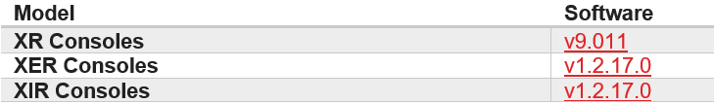
Select the appropriate software file to download based on your console model.
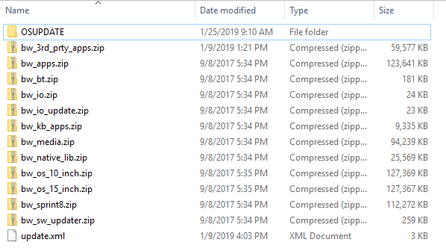
The contents of the root directory of the USB drive will look like the above image when extracted correctly.
- Insert the USB drive into the USB port on the front of the console.
- Power on the unit.
- Within 0.2 seconds after the relay on the LCB clicks or the console backlight turns on (about 1 second after flipping the power switch), press and hold the SPEED UP key (or RESISTANCE UP key on a bike, elliptical, or Ascent).
- While holding down SPEED UP, repeatedly press SPEED DOWN (or RESISTANCE DOWN) 9 to 10 times, at a rate of about 2 presses per second (the timing is similar to CPR compressions).
- Once you have pressed SPEED DOWN 9 or 10 times, release the SPEED DOWN key, but continue to hold SPEED UP for an additional 0.5 to 1.0 seconds before releasing.
Note: When attempting to access recovery mode using this sequence, if the animation that changes the display from the "Johnson logo" to the "Johnson triangle" begins to play, then the console did not successfully enter recovery mode. You will need to power the unit off and back on to reattempt steps 3 through 6.
This is the “Johnson logo” screen that appears shortly after powering on the unit.

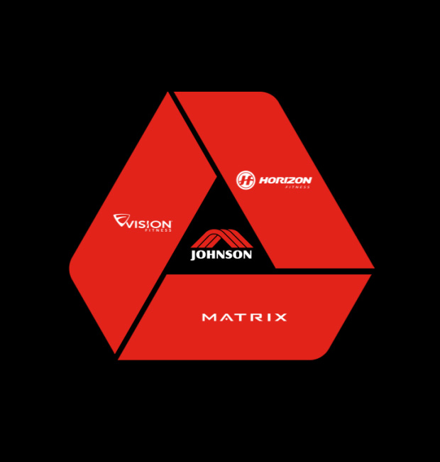
This is the “Johnson triangle” screen. If you see this image, you will need to power cycle the console and try again to enter recovery mode.

- If successful, the display will change within several seconds from the "JOHNSON" screen to an Android recovery mode screen. Press SPEED DOWN twice to highlight the "Restore from USB" option, then press SPEED UP to select it.
- The Operating System will reinstall over several minutes, after which you will be prompted to perform a touch screen calibration. Follow the instructions on the screen to complete the calibration.
- After calibrating the touch screen, the console will reinstall all software packages from the USB drive. Keep the USB drive inserted until the update is complete. The installation can take up to an hour, and the console will reboot itself several times during the process. When the installation is complete, the console will boot to the first-time setup process.

Note: It may take a dozen or more attempts before you are able to successfully enter recovery mode using the keypad. The hardest part for most people is timing when to begin holding down the SPEED UP key. If you are having difficulty, it may help to have a second person present to flip the power switch.

