**Updating Software on Matrix Retail**

At Matrix splash screen:

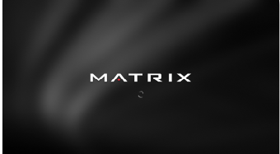

Insert the USB with the update software.

***For XIR consoles***, when the following screens appear, touch where highlighted in red:

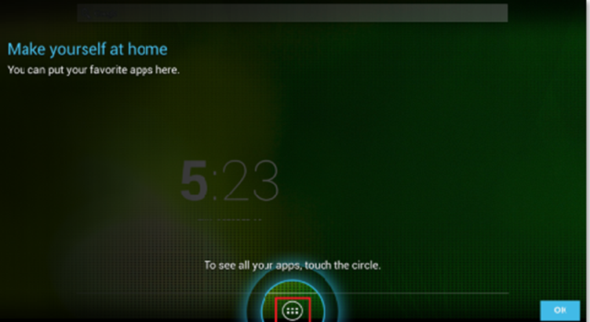

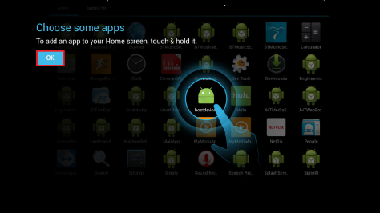

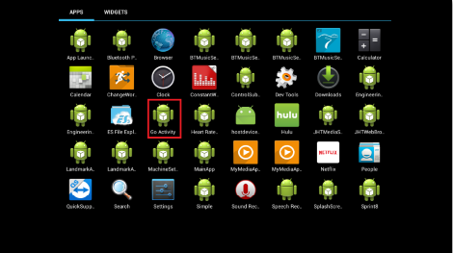

Expanded View: 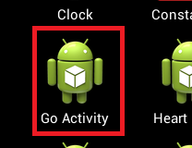

Select Machine Settings:

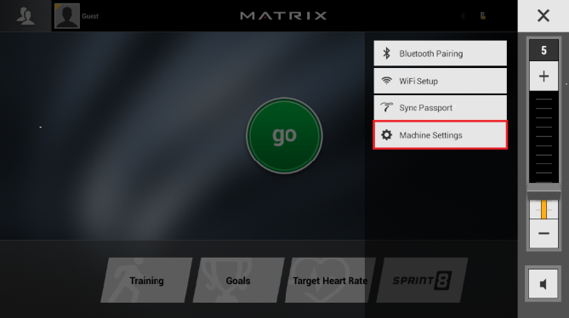

Select Update:

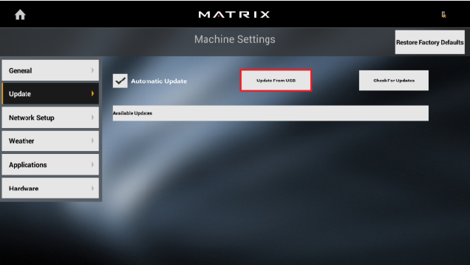

Select “***Update From USB”*** and verify that the following updates are available:

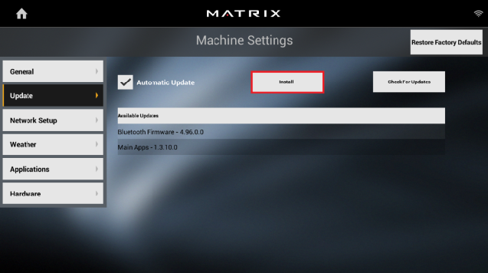

Selecting the ***Install*** button will launch the Software Install Screen:

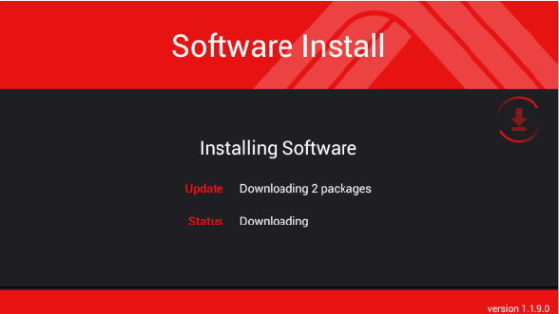

Once the “Install Complete” message appears on the console:

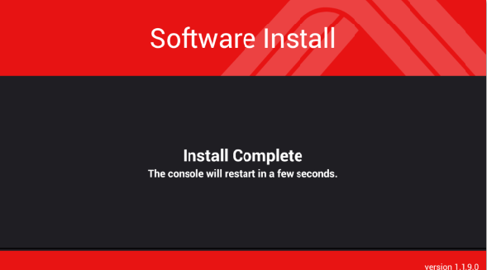

Remove the USB. After the install completes, the console should reboot to:

